OFF-CAMPUS ACCESSS

You need to follow these steps for using e-library.

1- Visit this page. It is the web address of e-library portal http://elibrary.altinbas.edu.tr/

2- Click on "register a new account". If you wish you can change the language.

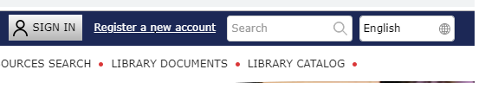
3- Fill the form. IMPORTANT: You must use your Altinbas e-mail account for E-mail (username) field. If you don't have an Altinbas e-mail yet please visit http://servicedesk.altinbas.edu.tr/ to have your institutional e-mail.
After filling the form click on "Submit"

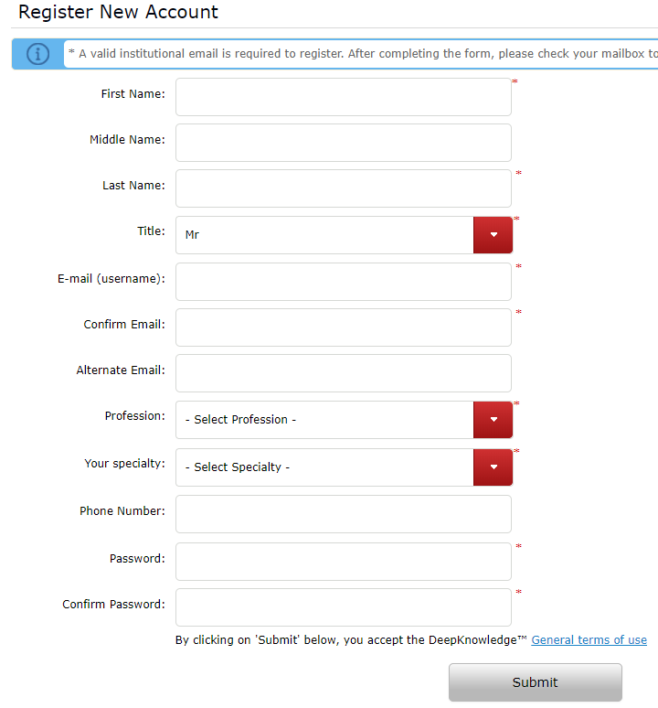
4- After you click on submit, an activation mail will send to you in a very short time. This activation mails usually drop to "spam" folder. Don't forget to check "spam folder" to see the activation mail.

5- Follow the procedures in the mail to activate your account. Than you will be able to access databases in university or outside of university.

6- If you face with any problem in registration process or if you need further information, you are always welcome to library and also you can send us e-mail (library@altinbas.edu.tr)

